IMPLEMENTATION OF STATISTICAL MODELING

Internship: YuvaIntern – Virtual Data Analysis Intern
Week: 4– Implementation of statistical modeling
Dataset: UCI Online Retail Dataset
Student: Moksha
Project: E-Commerce Sales and Customer Analytics

1. INTRODUCTION

Statistical modeling is an important part of data analysis because it helps identify patterns in data and develop models that can estimate or predict outcomes. After completing data acquisition, data cleaning, exploratory data analysis, and visualization in the previous weeks, this task focuses on implementing and evaluating a machine learning regression model.

This project uses the Online Retail dataset, which contains transaction records from an online retail business. The dataset includes information such as invoice details, product descriptions, quantities, unit prices, transaction dates, customer identifiers, and countries.

For this task, Random Forest Regression was selected to predict the quantity of products recorded in individual transaction lines. The model uses transaction price, date-derived features, and country information to generate quantity predictions.

The implementation includes data preparation, feature selection, model training, hyperparameter tuning, cross-validation, performance evaluation, and visualization. The results are compared with a simple baseline prediction to understand whether the trained model provides an improvement.

2. OBJECTIVES

The main objectives of this task are:

1. To select a suitable regression algorithm for the e-commerce transaction dataset.
2. To prepare the dataset for statistical modeling.
3. To identify appropriate input features and a target variable.
4. To divide the data into training and testing sets.
5. To train a Random Forest Regression model.
6. To perform hyperparameter tuning using cross-validation.
7. To evaluate the model using MAE, RMSE, and R-squared.
8. To compare the model with a simple baseline prediction.
9. To visualize actual and predicted values and examine prediction errors.
10. To identify model limitations and suggest possible improvements.

3. DATASET DESCRIPTION

The project uses the cleaned Online Retail dataset prepared during the previous stages of the E-Commerce Sales and Customer Analytics project.

The dataset contains transaction-level information that can be used to study purchasing patterns and develop a predictive model.

Important attributes include:

- InvoiceNo: Identifier associated with a transaction.
- StockCode: Product identification code.
- Description: Description of the product.
- Quantity: Number of units recorded in a transaction line.
- InvoiceDate: Date and time of the transaction.
- UnitPrice: Price per unit of the product.
- CustomerID: Identifier of the customer.
- Country: Country associated with the transaction.

For Week 4, the modeling script applies filters to prepare the data and selects 50,000 rows for model development. This sample was used to reduce computation time while keeping the experiment reproducible.

4. DATA PREPARATION AND PREPROCESSING

Data preparation is essential because the quality and format of input data can affect model performance.

The following preprocessing steps were implemented:

4.1 Loading the Dataset

The cleaned dataset was loaded from "online_retail_cleaned.csv" using the pandas library.

4.2 Handling Required Fields

The script prepared the relevant columns for modeling and removed records with missing values in the required date, quantity, unit price, or country fields.

4.3 Filtering Transaction Records

Records with non-positive quantities and non-positive unit prices were excluded from the modeling data. This ensured that the selected transaction records met the modeling filters used in the script.

4.4 Feature Engineering

The InvoiceDate column was used to derive additional time-related features:

- Month: The month in which the transaction occurred.
- DayOfWeek: The day of the week on which the transaction occurred.
- Hour: The hour at which the transaction occurred.

These features allow the model to consider basic temporal patterns in purchasing activity.

4.5 Selecting Input Features

The following five features were selected as model inputs:

1. UnitPrice
2. Month
3. DayOfWeek
4. Hour
5. Country

The target variable was Quantity.

4.6 Encoding Categorical Data

Country is a categorical variable. One-hot encoding was used to convert country categories into a numerical representation suitable for the regression pipeline.

4.7 Sampling for Computational Efficiency

A reproducible random sample of 50,000 rows was selected using a fixed random seed. This reduced the computational workload while allowing the experiment to be repeated with the same sampling procedure.

Table 1: Dataset preparation summary

Item| Details
Rows used for modeling| 50,000
Training data| 40,000 rows
Testing data| 10,000 rows
Training proportion| 80%
Testing proportion| 20%
Random state| 42
Target variable| Quantity

5. MODEL SELECTION: RANDOM FOREST REGRESSION

Random Forest Regression was selected for this task because it can model nonlinear relationships between input variables and a numerical target.

Random Forest is an ensemble learning algorithm that builds multiple decision trees and combines their predictions to produce a final result. For regression, the predictions from the individual trees are generally averaged.

The algorithm can capture relationships that may not be represented adequately by a simple linear model. It can also work with a mixture of numerical features and encoded categorical variables.

Reasons for selecting Random Forest Regression

- It can learn nonlinear relationships between transaction attributes and quantity.
- It can model interactions between different input features.
- It combines multiple decision trees rather than relying on a single tree.
- It does not require the target to have a linear relationship with each feature.
- It provides a practical approach for experimenting with transaction-level regression.

The model was selected as an experimental predictive approach, not because its performance was guaranteed to be high. Its effectiveness was assessed using the test dataset and evaluation metrics.

6. TRAINING AND TESTING METHODOLOGY

The prepared dataset was divided into training and testing subsets using an 80:20 split.

6.1 Training Set

The training set contained 40,000 rows. It was used to fit the regression model and perform hyperparameter tuning.

6.2 Testing Set

The testing set contained 10,000 rows. It was held out from model fitting and used to evaluate the final selected model.

6.3 Reproducibility

A random state of 42 was used for the train-test split and relevant randomized operations. A fixed random state helps reproduce the experiment under the same data and software conditions.

6.4 Model Pipeline

The modeling pipeline combines preprocessing and regression. Country values are one-hot encoded, numerical and date-derived features are passed through, and the transformed features are supplied to the Random Forest Regressor.

This pipeline keeps the preprocessing and modeling steps organized within the same workflow.

7. HYPERPARAMETER TUNING AND CROSS-VALIDATION

Hyperparameters are settings selected before or during model configuration that control how a learning algorithm is trained. Choosing suitable values can influence model performance and computational cost.

RandomizedSearchCV was used to evaluate candidate Random Forest configurations. Mean Absolute Error was used as the scoring criterion, with lower values preferred.

Three-fold shuffled cross-validation was used during the experiment. In this process, the training data is divided into three folds. Each fold is used as a validation set once while the remaining folds are used for training. The validation results are then aggregated to compare candidate configurations.

The tuning procedure evaluated six candidate configurations, with three-fold cross-validation for each candidate.

Table 2: Best hyperparameter configuration

Hyperparameter| Selected value| Purpose
"n_estimators"| 100| Number of decision trees
"max_depth"| 20| Maximum depth of each tree
"min_samples_split"| 10| Minimum samples required to split a node
"min_samples_leaf"| 1| Minimum samples required at a leaf node

The best configuration was selected based on cross-validation performance. The resulting model was then evaluated on the held-out test dataset.

8. MODEL EVALUATION METRICS

Three principal metrics were used to evaluate the regression model: Mean Absolute Error, Root Mean Squared Error, and R-squared. A median-prediction baseline was also used for comparison.

8.1 Mean Absolute Error (MAE)

MAE measures the average absolute difference between actual and predicted values.

Interpretation: A lower MAE indicates that predictions are closer to the actual values on average.

The model achieved an MAE of 7.486046. Therefore, the average absolute prediction error was approximately 7.49 quantity units.

8.2 Root Mean Squared Error (RMSE)

RMSE measures the square root of the average squared prediction errors. Because the errors are squared before averaging, large errors have a greater influence on the result.

Interpretation: A lower RMSE generally indicates better prediction accuracy, and a large difference between RMSE and MAE can indicate the presence of some larger errors.

The model achieved an RMSE of 24.449051.

8.3 R-squared

R-squared indicates how much of the variation in the target variable is explained by the model relative to a mean-based reference.

Interpretation: A value closer to 1 generally indicates stronger explanatory performance. A value near 0 indicates limited explanatory power relative to that reference.

The model achieved an R-squared score of 0.235261, or approximately 23.53%.

This suggests that the model explains a limited proportion of the observed variation in Quantity.

8.4 Baseline Comparison

A baseline model provides a simple reference against which the more complex model can be compared. In this experiment, the median quantity from the training data was used as a constant prediction for the test observations.

The baseline achieved an MAE of 8.265500, compared with the Random Forest model's MAE of 7.486046.

The Random Forest model therefore achieved a lower test MAE than the median-prediction baseline.

9. RESULTS AND PERFORMANCE ANALYSIS

The final test results are summarized below.

Table 3: Statistical modeling results

Metric| Result
Mean Absolute Error (MAE)| 7.486046
Root Mean Squared Error (RMSE)| 24.449051
R-squared| 0.235261
Baseline median-prediction MAE| 8.265500
Best cross-validation MAE| 8.088187

9.1 Interpretation of Results

The test MAE of 7.486046 indicates that the model's predictions differ from the actual quantities by about 7.49 units on average when absolute differences are considered.

The test RMSE of 24.449051 is considerably higher than the MAE. This suggests that larger prediction errors have a meaningful effect on the overall error measurement. The skewed distribution of transaction quantities may contribute to this result, although further residual analysis would be needed to confirm the causes.

The R-squared score of 0.235261 indicates that the model has limited explanatory power. The selected features do not capture all the factors that influence product quantities in individual transactions.

The test MAE is lower than the baseline MAE, showing that the Random Forest model provides an improvement over the simple constant-prediction approach under this evaluation setup.

The best cross-validation MAE was 8.088187. It is not identical to the test MAE because cross-validation and test evaluation use different subsets of data.

Overall, the results demonstrate that the model learned some useful relationships, but additional features, validation methods, and model comparisons would be needed to improve its predictive performance.

10. DATA VISUALIZATION AND INTERPRETATION

Visualizations help communicate model performance and identify patterns that may not be obvious from numerical metrics alone.

The Week 4 script generates three charts. The following images should be inserted from the "Week4_Results/charts" folder.

10.1 Actual vs. Predicted Quantities

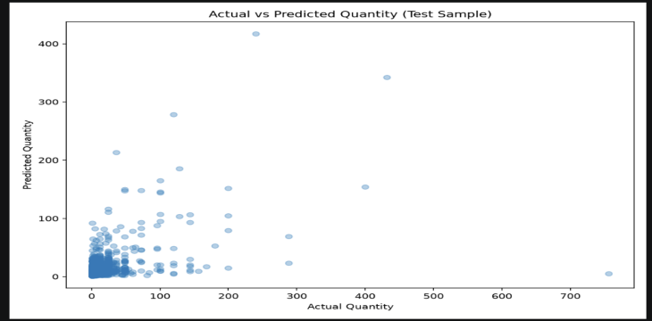

Fig1: actual_vs_predicted

This chart compares the actual quantity values with the quantities predicted by the Random Forest model. Predictions that align closely with the ideal relationship between actual and predicted values indicate smaller errors. Points spread widely away from that relationship indicate less accurate predictions.

The chart helps visually assess how well the model estimates quantities across the test observations.

10.2 Prediction Errors

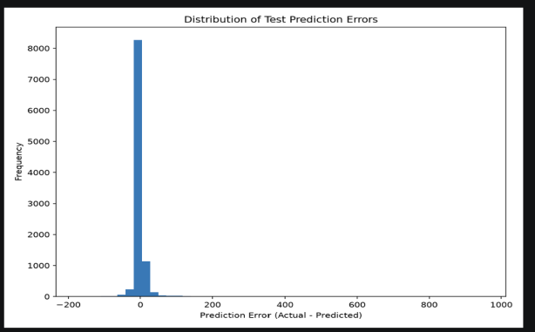

Fig2: prediction_errors

Prediction errors, also called residuals, represent the differences between actual and predicted values. This chart helps examine the distribution of those errors and identify whether some predictions have much larger errors than others.

Residual patterns can help identify weaknesses in a model and suggest whether additional features or a different modeling approach may be useful.

10.3 Model Metrics

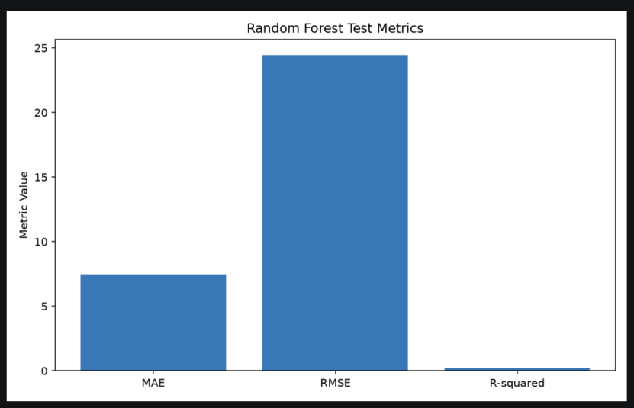

Fig 3: model_metrics.png

This chart provides a visual summary of the model's evaluation metrics. It should be interpreted alongside the numerical results table because MAE, RMSE, and R-squared have different meanings and may use different scales.

Together, the charts and metric table provide a clearer picture of the model's performance and limitations.

11. ASSUMPTIONS AND LIMITATIONS

Although the model completed successfully, several limitations should be considered when interpreting the results.

11.1 Limited Feature Selection

The model uses only UnitPrice, Month, DayOfWeek, Hour, and Country. Product-level characteristics, customer purchasing behavior, invoice-level patterns, and other potentially useful information were not included.

11.2 Skewed Target Distribution

Transaction quantities can vary substantially, with some unusually large quantities. These observations may contribute to larger prediction errors and influence RMSE.

11.3 Limited Predictive Performance

The R-squared score of 0.235261 indicates that a considerable amount of variation in Quantity remains unexplained by the selected features.

11.4 Random Train-Test Split

A random split may place transactions from the same invoice or nearby time periods in both the training and test sets. Consequently, these results measure performance on a random holdout rather than performance when predicting a genuinely future time period.

11.5 Sampling

The experiment uses a sample of 50,000 rows rather than the entire cleaned dataset. The results may differ when a larger dataset or a different sampling strategy is used.

11.6 Prediction Errors

The RMSE is considerably higher than the MAE, indicating that some large errors may be present. Additional residual analysis is required to understand the observations contributing most to these errors.

11.7 No Future Forecasting Claim

The model predicts transaction quantity using selected attributes. It has not been validated as a time-series forecasting model and should not be described as reliably predicting future sales without additional experiments.

12. POSSIBLE IMPROVEMENTS

The following improvements could be explored in future iterations:

1. Add more relevant features: Include product identifiers, customer purchase history, invoice-level information, and other features when suitable.
2. Use time-based validation: Train on earlier transactions and evaluate on later transactions to measure performance on future periods.
3. Compare multiple algorithms: Evaluate Decision Tree Regression, linear regression, and Gradient Boosting alongside Random Forest.
4. Study the target distribution: Examine extreme quantity values and consider appropriate transformations or robust modeling approaches when justified.
5. Analyze residuals: Investigate the observations associated with large errors to identify patterns the model fails to capture.
6. Evaluate different segments: Compare model performance across countries, months, and quantity ranges.
7. Test larger samples: Assess whether using more data improves performance without exceeding available computational resources.
8. Review feature importance: Investigate which input variables contribute most to the model's predictions, while interpreting importance measures cautiously.

These improvements could help determine whether the model can become more accurate and more useful for practical retail analytics.

13. LEARNING OUTCOMES

Through this task, I gained practical experience in implementing a regression modeling workflow.

The key learning outcomes were:

- Understanding the purpose of regression modeling.
- Selecting a suitable model for a numerical target variable.
- Preparing data and creating time-related features.
- Encoding categorical variables for machine learning.
- Splitting data into training and testing subsets.
- Training a Random Forest Regression model.
- Applying hyperparameter tuning and cross-validation.
- Interpreting MAE, RMSE, and R-squared.
- Comparing model performance with a simple baseline.
- Understanding the importance of feature selection and validation design.
- Identifying limitations and proposing improvements based on the observed results.

The task also demonstrated that using a more complex algorithm does not automatically guarantee high predictive accuracy. Data quality, feature relevance, target distribution, and evaluation strategy all influence the results.

14. CONCLUSION

In this Week 4 task, a Random Forest Regression model was implemented to predict the Quantity variable in the Online Retail transaction dataset. The workflow included data preparation, feature selection, train-test splitting, categorical encoding, hyperparameter tuning, cross-validation, and model evaluation.

The model was trained using 40,000 rows and evaluated on 10,000 test rows selected from a reproducible sample of 50,000 rows.

The final model achieved a Mean Absolute Error of 7.486046, a Root Mean Squared Error of 24.449051, and an R-squared score of 0.235261. Its MAE was lower than the baseline median-prediction MAE of 8.265500, indicating better performance than the simple baseline on this test set.

However, the R-squared score indicates limited predictive power, and the relatively high RMSE suggests that larger prediction errors deserve further investigation. The results should also be interpreted in light of the random train-test split and the use of a sample rather than the entire cleaned dataset.

This task provided practical experience in statistical modeling and demonstrated the importance of evaluating machine learning models critically. Future work should focus on more informative features, time-aware validation, residual analysis, and comparisons with alternative regression algorithms.

